

LAB REPORT

|  |
| --- |
| 03 |

CSE416: Web Engineering Lab

Submitted To

Md. Ashraful Islam Talukder

Lecturer

Department of CSE

Daffodil International University

Submitted By

Student ID: 221-15-5606

Student Name: Mahmudul Hasan Piash

Section: 61_D1

Department of CSE

Daffodil International University

Date of Assignment Distribution: 13th July, 2025

Date of Assignment Submission: 13th July, 2025

|  |  |
| --- | --- |
| Experiment No: 03 | Experiment Name: Data Insertion from a static web page to database using PHP. |

Obtained Output:

This is a SS of the main Page.



This is the SS of Register Page.

After Giving Proper Information, it goes to next page.



Without giving Proper Info.

Database SS.

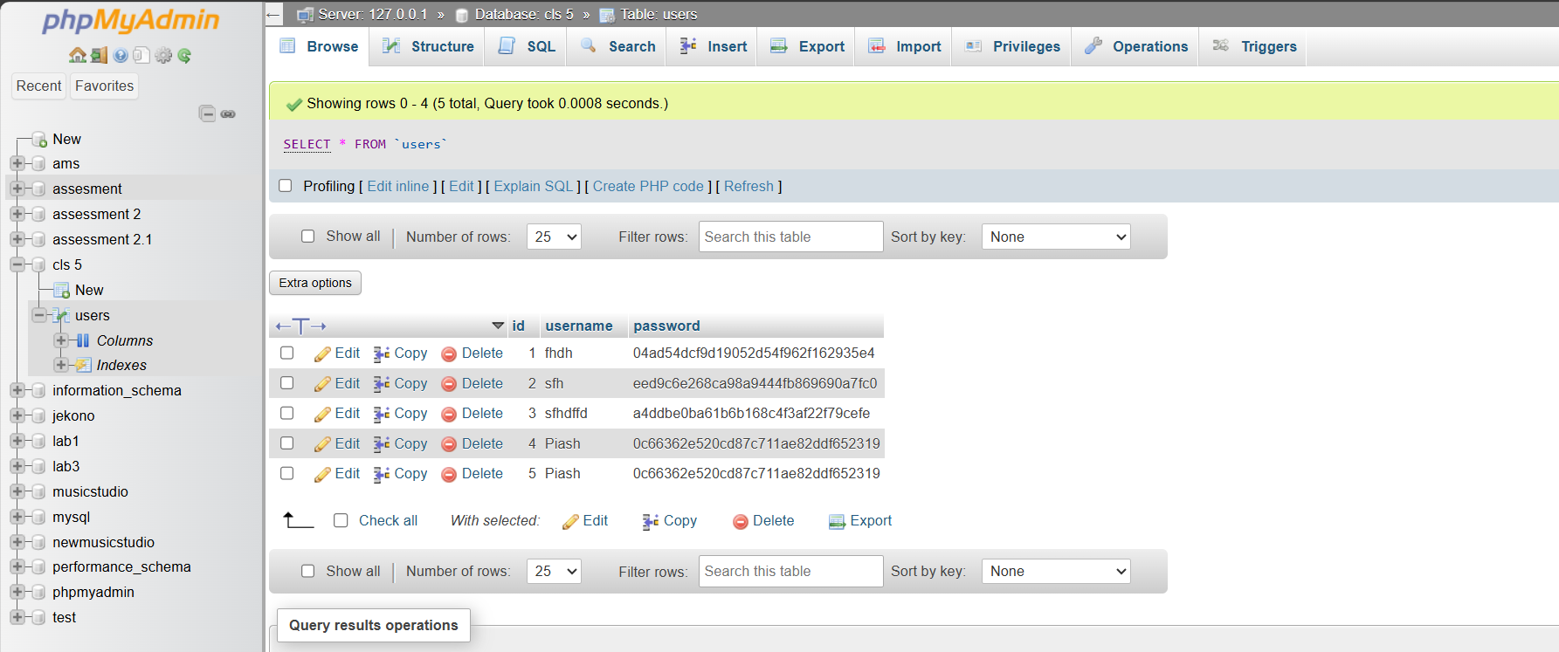

**Source Code**

Main.html

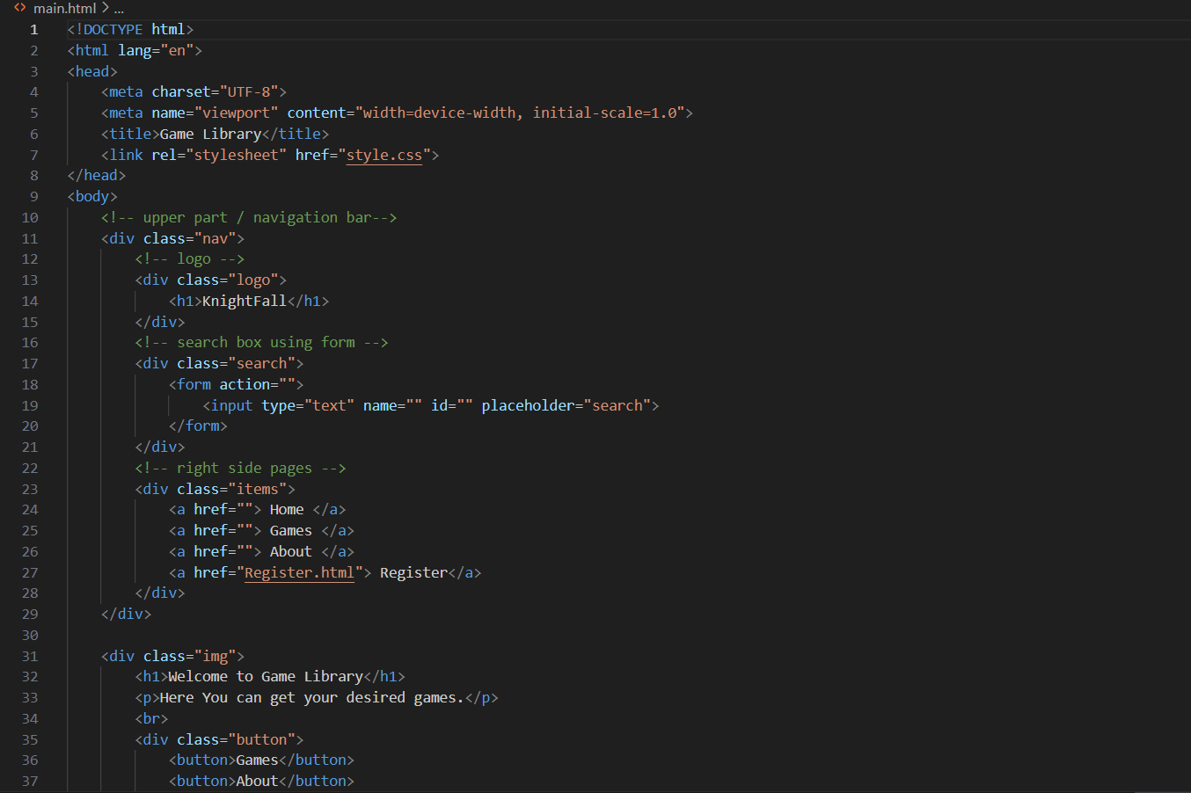

Register.html

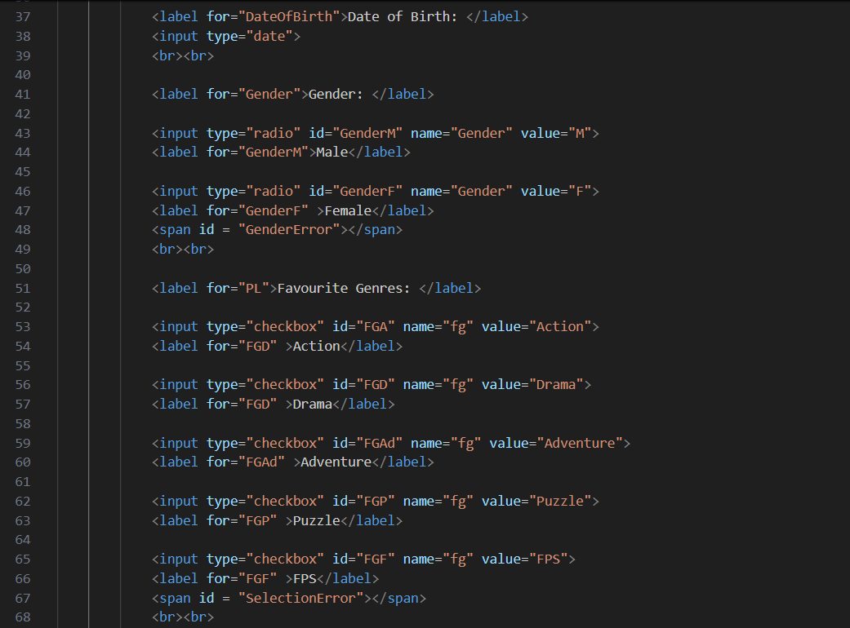

dbcon.php

* Here $host is localhost , $user is root, $password is empty, and $db is "cls 5".
* Then attempting to connecting to the MySQL database using mysqli_connect() with these informations.
* Then we are checking if the connection was successful or not.

Login.php

This PHP file is for query run. Here,

* Got value of username and password from html file and stored it in $un and $pass.
* With $run we are sending data to the database.
* By checking if we can see if the query is successful or failed.

Style.css

LoginStyle.css

